**Photoelectric total solar radiation**

**(Model 485)**

**Pr-300 al-ra-n01**

**VER 2.0**



Table of contents

Chapter 1 introduction

1.1 product overview

1.2 functional features

1.3 main parameters

1.4 system diagram

1.5 product selection

Chapter 2 hardware connectivity

2.1 equipment inspection before installation

2.2 interface instructions

2.2.1 sensor wiring

2.3 installation

Chapter 3 configuration software installation and use

3.1 the sensors are connected to the computer

3.2 use of sensor monitoring software

Chapter 4 communication protocols

4.1 basic communication parameters

4.2 data frame format definition

4.3 register address

4.4 examples and explanations of communication protocols

4.4.1 read the current solar radiation

4.4.2 write deviation

4.4.3 modify the current address

4.4.4 change current baud rate

4.4.5 find the current address

Chapter 5 common problems and solutions

Chapter 6 product maintenance

# Chapter 1 introduction

## 1.1 product overview

PR-300AL-RA-N01 solar total radiation sensor adopts photoelectric principle, which can be used to measure solar radiation in the spectral range of 0.3 ~ 3μm. The radiation sensor adopts high precision sensor, wide spectrum absorption, high absorption in the whole spectrum range and good stability, at the same time, the sensor is equipped with dust cover with light transmittance up to 95% , and the dust cover adopts special treatment, reduce dust adsorption, effectively prevent environmental factors on the internal components of the interference, can be more accurate measurement of solar radiation.

The product adopts Standard Modbus-RTU 485 communication protocol, can directly read the current solar radiation value, wiring mode is simple. It is small and beautiful, and takes up little installation space. The products are widely used in solar energy utilization, meteorology, agriculture, building materials aging and air pollution and other departments to do solar radiation energy measurement.

## 1.2 functional characteristics

High-precision sensor, high absorption in the whole spectrum

It has its own level meter and adjusting handwheel, which is convenient to adjust on site

Adopt Standard Modbus-RTU protocol

High transparent dust cover, good sensitivity, special surface treatment to prevent dust adsorption

Power supply DC 7 ~ 30V with wide voltage

## 1.3 main parameters

|  |  |
| --- | --- |
| Power supply area | 7 V to 30 V DC |
| Output mode | 485(standard Modbus-RTU protocol) |
| Power consumption | 0.06 W |
| Working humidity | 0% ~ 100% Rh |
| Operating temperature | -25 ° C ~ 60 ° C |
| The object of measurement | Sunlight |
| Measuring range | 0-2,000 w/m2 |
| Precision | ± 5% |
| Wavelength range | 400-1100 nm |
| Resolution | 1W/M 2 |
| Response time | ≤10 s |
| Nonlinear | < ± 2% |
| Annual stability | ≤ ± 2% |
| Cosine response | ≤ ± 10% |

**Shell dimensions**

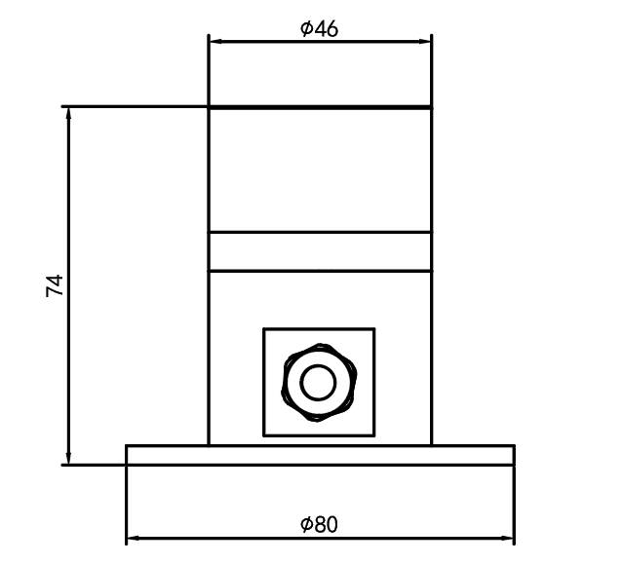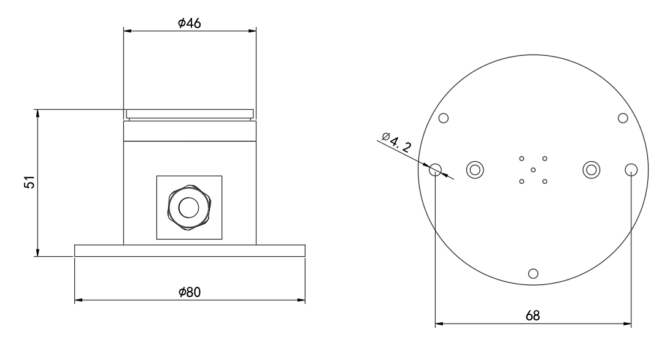

## System diagram

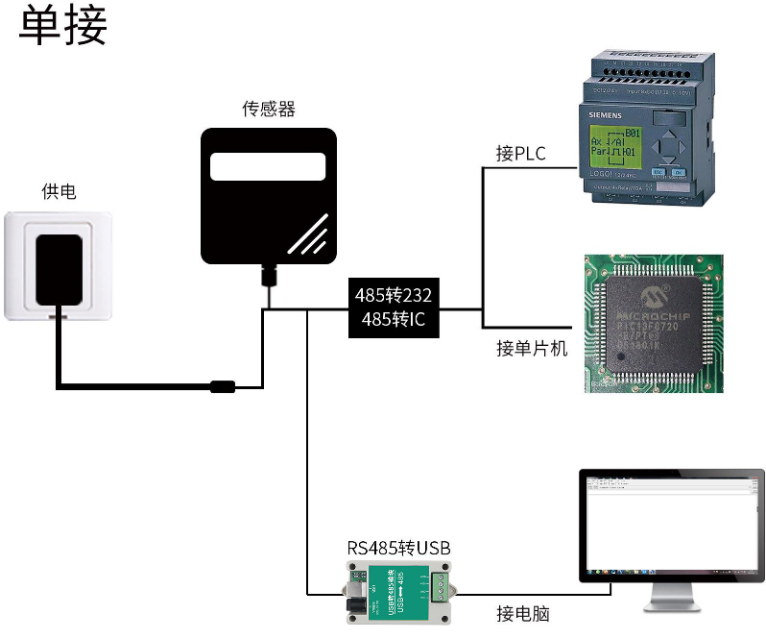

The product can also be used in a combination of multiple sensors in a 485 bus, in theory a bus can be 254485 sensors, the other end with a 485 interface PLC, 485 interface chip connected with the MCU, or use USB to 485 can be connected to the computer, the use of my company's sensor configuration tools for configuration and testing (use the configuration software can only be connected to one device) .

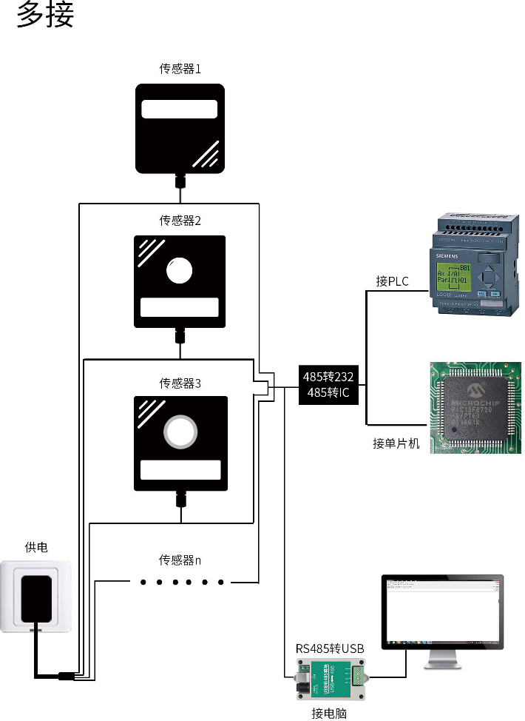

## 1.5 product selection

|  |  |  |  |  |
| --- | --- | --- | --- | --- |
| PR - |  | | | Company code name |
|  | 300 Al - |  | | Aluminum case |
|  | RA - |  | Total solar radiation sensor |
|  | N01 | 485 output (standard Modbus-RTU) |

# Chapter 2 hardware connectivity

## 2.1 equipment pre-installation inspection

Equipment list:

Main equipment

Black waterproof pair cable 70cm

Certificate

## 2.2

Power interface for wide voltage input 7-30V. 485 signal line wiring attention to A-B two lines can not be connected back, the bus address between multiple devices can not conflict.

### 2.2.1 sensor wiring

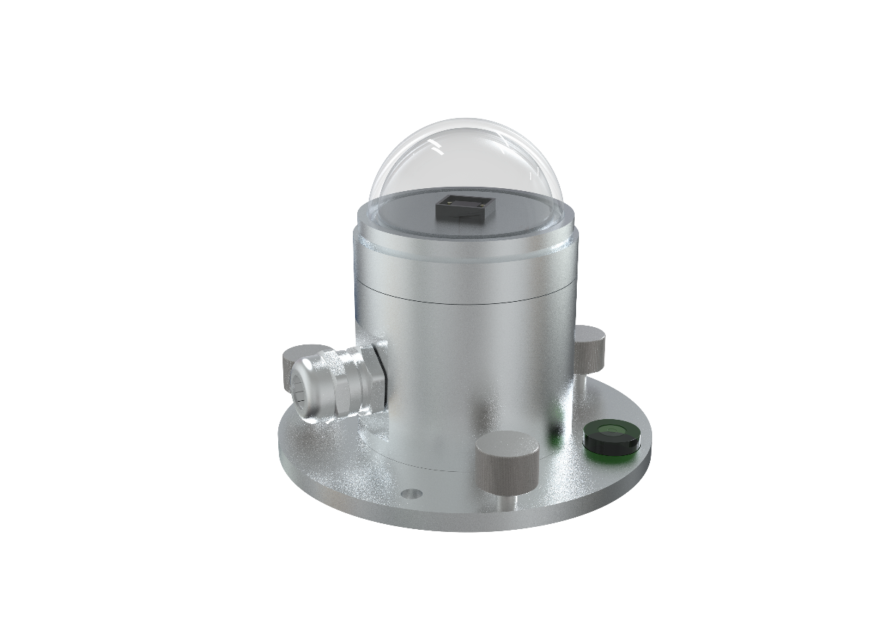

|  |  |  |
| --- | --- | --- |
|  | Color | Description |
| 电  源 | Brown | Power supply positive (7 ~ 30V DC) |
| Black | The power supply is negative |
| 通  信 | Green | 485-A |
| Blue | 485-B |

## 2.3 installation

The sensor is fixed on the mounting bracket through the mounting hole of the sensor by using a screw

Make sure the device is parallel to the ground (adjust the hand screw and check the horizontal bubble status to see if it is parallel)

After installation, remove the protective cover

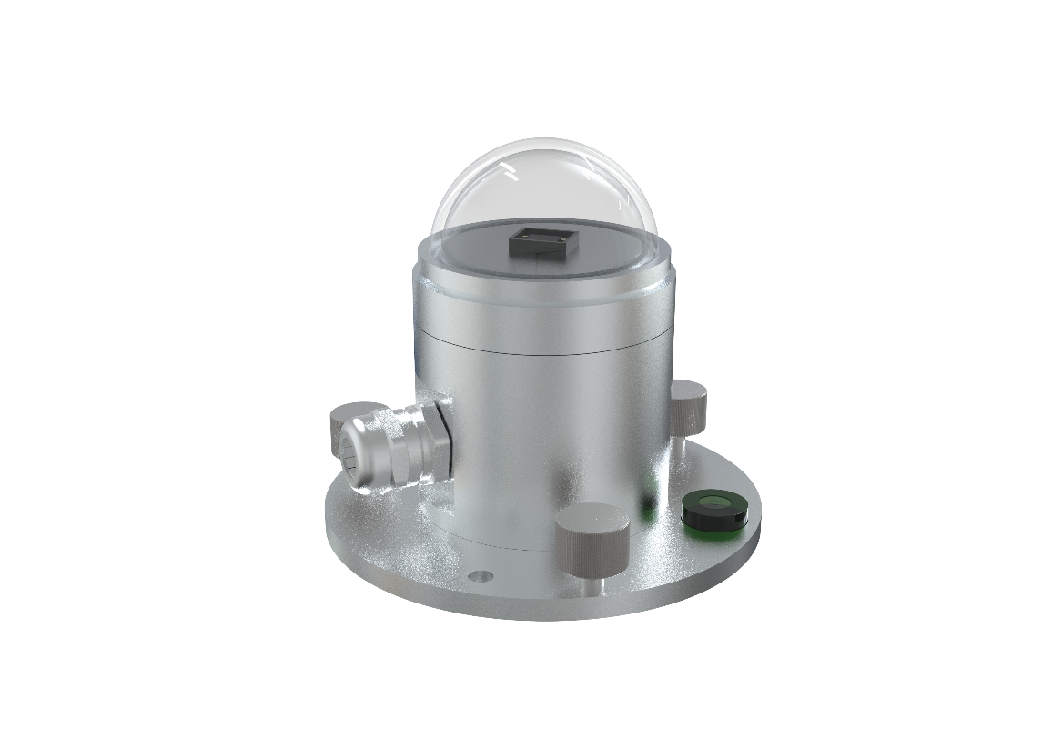

# Chapter 3 configuration software installation and use

We provide the supporting“485 parameter configuration software”, can easily use the computer to read the parameters of the sensor, while flexible modification of the sensor device ID and address.

Note that using software for automatic acquisition requires ensuring that there is only one sensor on the 485 bus.

## 3.1 the sensor is connected to the computer

After connecting the sensor to the 485 via USB and powering it properly, you can see the correct COM port on your computer (see the COM port in my pc-properties-device manager-port) .

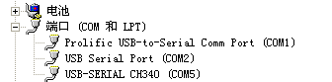

Open the package, select“Debugging software”-“485 parameter configuration software”, find to open.

If you do not find a COM port in device manager, it means that you do not have a USB to 485 driver installed (in the package) or you do not have the driver installed correctly, please contact a technical person for help.

## 3.2 use of sensor monitoring software

Configuration interface as shown in the figure, first according to Section 3.1 method to get the serial port number and select the correct serial port.

Click on the test baud rate of the software, the software will test the current device baud rate and address, the default baud rate is 4800 bit/s, the default address is 0x01.

3. Change the address and baud rate as needed, and query the current function status of the device.

If the test is not successful, please re-check the wiring and 485 driver installation.

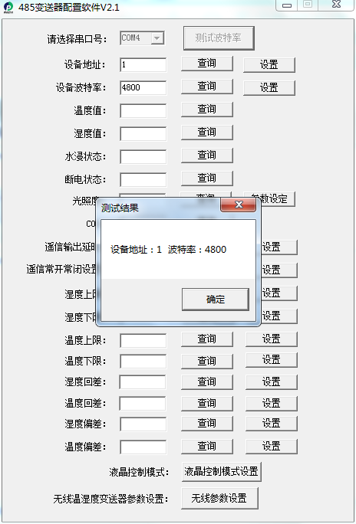

# Chapter 4 Communication Protocol

## 4.1 basic communication parameters

|  |  |
| --- | --- |
| Code | 8-bit binary |
| Data bits | 8 bits |
| Parity bit | 无 |
| Stop bit | 1 |
| Error checking | CRC (redundant cyclic code) |
| Baud rate | 2400bit/s, 4800bit/s, 9600bit/s can be set, the factory default is 4800bit/s |

## 4.2 data frame format definition

Using Modbus-RTU protocol, the format is as follows:

Initial structure ≥4 bytes of time

Address code = 1 byte

Function code = 1 byte

Data area = N bytes

Error Check = 16-bit CRC code

Time to end structure ≥4 bytes

Address Code: the address of the transmitter, which is unique in the communication network (factory default 0x01) .

Function code: this transmitter only uses the function code 0x03(reads register data) .

Data area: Data area is the specific communication data, note 16bits data high bytes in front!

CRC code: two-byte checksum code.

Host queries frame structure:

|  |  |  |  |  |  |
| --- | --- | --- | --- | --- | --- |
| Address Code | Function codes | Register start address | Register length | Low checksum | Check code high bit |
| 1 byte | 1 byte | 2 bytes | 2 bytes | 1 byte | 1 byte |

Slave reply frame structure:

|  |  |  |  |  |  |  |
| --- | --- | --- | --- | --- | --- | --- |
| Address Code | Function codes | Number of valid bytes | Data Area One | Second data area | The N data area | Check Code |
| 1 byte | 1 byte | 1 byte | 2 bytes | 2 bytes | 2 bytes | 2 bytes |

## 4.3 register addresses

|  |  |  |  |
| --- | --- | --- | --- |
| Register address | Contents | Operation | Description of scope and definition |
| 0000h | Solar radiation | Read only | True Value |
| 0052H | Deviation values | Read and write | Solar radiation deviation (0-1800) |
| 07D0H | Device address | Read and write | 1-254(factory default 1) |
| 07D1H | Device Baud rate | Read and write | Zero is 2400  One is 4800  2 is 9,600 |

## 4.4 examples and explanations of communication protocols

### 4.4.1 read current solar radiation

Query frame: read numeric function code 03/04

|  |  |  |  |  |  |
| --- | --- | --- | --- | --- | --- |
| Address Code | Function codes | Starting address | Data Length | Low checksum | Check code high bit |
| 0x01 | 0x03 | 0x000x00 | 0x000x01 | 0x84 | 0x0A |

Response Frame

|  |  |  |  |  |  |
| --- | --- | --- | --- | --- | --- |
| Address Code | Function codes | Returns the number of valid bytes | Solar radiation | Low checksum | Check code high bit |
| 0x01 | 0x03 | 0x02 | 0x000x64 | 0x9B | 0xAF |

Solar radiation:

0064(hexadecimal) = 100 = > solar radiation = 100 w/m2

### 4.4.2 write the deviation value

Query frame: write numeric function code 06/10

|  |  |  |  |  |  |
| --- | --- | --- | --- | --- | --- |
| Address Code | Function codes | Register address | Modify the numeric value | Low checksum | Check code high bit |
| 0x01 | 0x06 | 0x000x52 | 0x000x0a | 0xA8 | 0x1C |

Response Frame

|  |  |  |  |  |  |
| --- | --- | --- | --- | --- | --- |
| Address Code | Function codes | Register address | Modify the numeric value | Low checksum | Check code high bit |
| 0x01 | 0x06 | 0x000x52 | 0x000x0a | 0xA8 | 0x1C |

Writes the current solar radiation offset

000A (hexadecimal) = 10 = > solar radiation deviation value = 10 w/M2 deviation value is 10 w/m2

### 4.4.3 modify the current address

Query frame (change current address to 0x02)

|  |  |  |  |  |  |
| --- | --- | --- | --- | --- | --- |
| Address Code | Function codes | Starting address | Modify the numeric value | Low checksum | Check code high bit |
| 0x01 | 0x06 | 0x070xd0 | 0x000x02 | 0x08 | 0x86 |

Response Frame

|  |  |  |  |  |  |
| --- | --- | --- | --- | --- | --- |
| Address Code | Function codes | Starting address | Modify the numeric value | Low checksum | Check code high bit |
| 0x01 | 0x06 | 0x070xd0 | 0x000x02 | 0x08 | 0x86 |

### 4.4.4 modifies the current baud rate

Frame of inquiry (assuming a modified baud rate of 9600)

|  |  |  |  |  |  |
| --- | --- | --- | --- | --- | --- |
| Address Code | Function codes | Starting address | Modify the numeric value | Low checksum | Check code high bit |
| 0x01 | 0x06 | 0x070xd1 | 0x000x02 | 0x59 | 0x46 |

Response Frame

|  |  |  |  |  |  |
| --- | --- | --- | --- | --- | --- |
| Address Code | Function codes | Starting address | Modify the numeric value | Low checksum | Check code high bit |
| 0x01 | 0x06 | 0x070xd1 | 0x000x02 | 0x59 | 0x46 |

### 4.4.5 query the current address

Frame of inquiry:

|  |  |  |  |  |  |
| --- | --- | --- | --- | --- | --- |
| Address Code | Function codes | Starting address | Data Length | Low checksum | Check code high bit |
| 0xFF | 0x03 | 0x070xd0 | 0x000x02 | 0x91 | 0x59 |

Response Frame

|  |  |  |  |  |  |  |
| --- | --- | --- | --- | --- | --- | --- |
| Address Code | Function codes | Returns the number of valid bytes | Address | Baud rate | Low checksum | Check code high bit |
| 0xFF | 0x03 | 0x04 | 0x000x01 | 0x000x01 | 0x50 | 0x50 |

The actual address read to the device is 01, and the baud rate is 0x01, or 4800.

# Chapter 5 common problems and solutions

**Points to note:**

When the customer receives the product, please confirm the product model and so on

Do not live wiring, wiring check, before power

Sensors are precision devices, do not remove the protective transparent cover

**Troubleshooting:**

If the value is zero, check if there is a light source and if the product cover is removed

The 485 bus is disconnected, or the A and B wires are connected back

Check that the power supply matches the label

Equipment damaged

# Chapter 6 product maintenance

Dust cover should be kept clean, regularly wipe with soft cloth

Dust cover can not have water, such as heavy rain, snow, ice and other weather for a long time, it is recommended that the best cover.